
STUDENT CASE STUDY EXECUTION REPORT
Department | FED
Subject | DSA-2
Academic Year | I-III semester(2025-26)
Faculty Name | Sukanya
Student Name | Devaji Rashmika
Roll Number | 2520090152
Branch | CSIT
Course Outcome

Case Study Topic: Snapdeal Product-Catalog Sorting using Timsort Algorithm
Work Done Summary:
In this case study, we implemented the core concepts of the Timsort algorithm used in Python and Java’s Arrays.sort(Object[]).
The product catalog data contained partially sorted segments similar to real-world e-commerce workloads where new products are appended daily.
We identified natural ascending and descending runs, reversed descending runs, applied insertion sort for small runs, and merged them stably to produce the final sorted catalog.
We also analysed the complexity of Timsort, compared it with Merge Sort, Quick Sort, and Heap Sort, and studied the advantage of galloping mode on nearly sorted data.
Implementation Details:
- Detected natural ascending and descending runs in the array.
- Reversed descending runs to convert them into ascending order.
- Applied insertion sort for short runs.
- Merged all runs stably using merge operations.
- Analysed run-detection complexity and insertion-sort complexity.
- Compared Timsort with Heap Sort, Merge Sort, and Quick Sort.
- Studied galloping mode optimization for highly uneven merges.

Result: Screenshots / Output
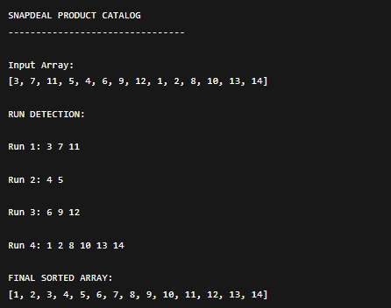

Complexity Analysis
(i) Run Detection Complexity
$$O(n)$$
Each element is scanned once while identifying ascending or descending runs.

(ii) Insertion Sort Complexity
$$O(k^{2})$$
Where:
- $k$= size of the small run.
Insertion sort is efficient for small nearly sorted segments.

(iii) Why Timsort is Superior to Merge Sort
- Exploits already sorted runs.
- Performs fewer comparisons on partially sorted data.
- Adaptive and stable.
- Faster on real-world datasets containing ordered segments.
- Uses insertion sort for small runs and merge sort for large runs.

Timsort vs Alternatives
Algorithm | Average Case | Worst Case | Best Case | Stable | Space
Quick Sort | O(n log n) | O(n²) | O(n log n) | No | O(log n)
Heap Sort | O(n log n) | O(n log n) | O(n log n) | No | O(1)
Merge Sort | O(n log n) | O(n log n) | O(n log n) | Yes | O(n)
Timsort | O(n log n) | O(n log n) | O(n) | Yes | O(n)

Galloping mode in Timsort speeds up merging by skipping multiple comparisons using exponential search when one run repeatedly wins during merge.

GitHub Link:
Student Signature | Faculty Signature

